# Australian EV Charging Stations – Report

* Vinit Shetty

## **MAP VISUALIZATION.**

1. **Marked EV Charging Stations for Australia.**

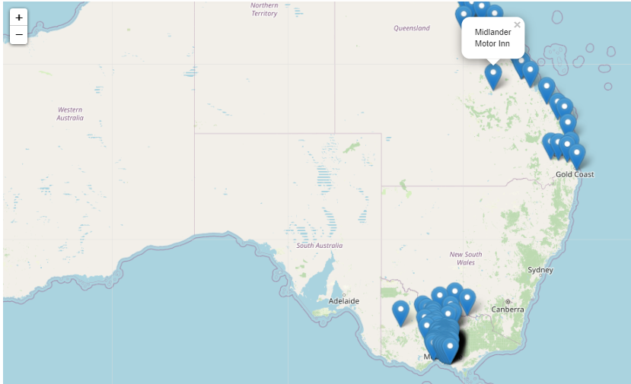

1. **Cluster-wise EV Charging Stations for Victoria.**

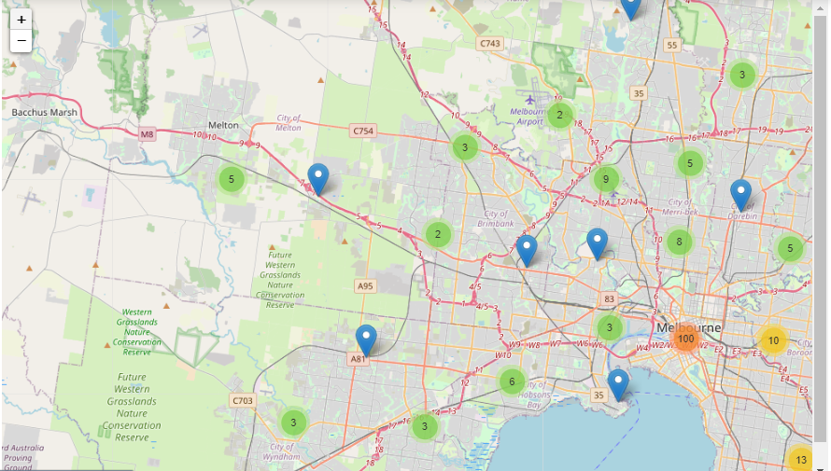

## **ROUTE OPTIMIZATION.**

1. **Route optimization is displayed between Cobram and Melbourne City.**

The estimated time to reach is 3.22 Hours with a distance travelled of 304 km between them. Only the EV Charging stations within the 5 km radius of the route are displayed to the user on the map.

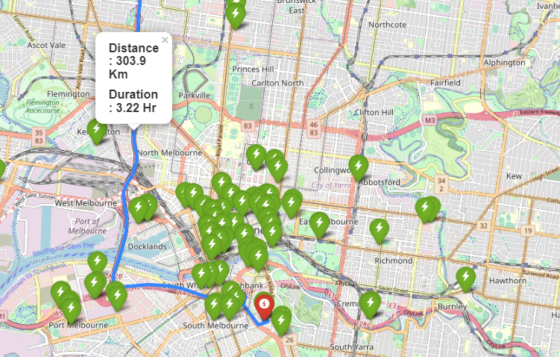

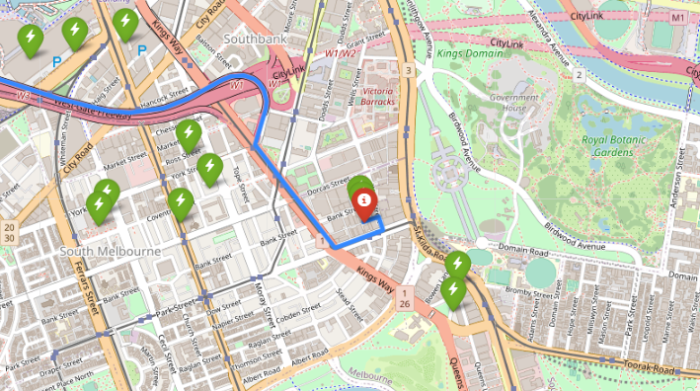

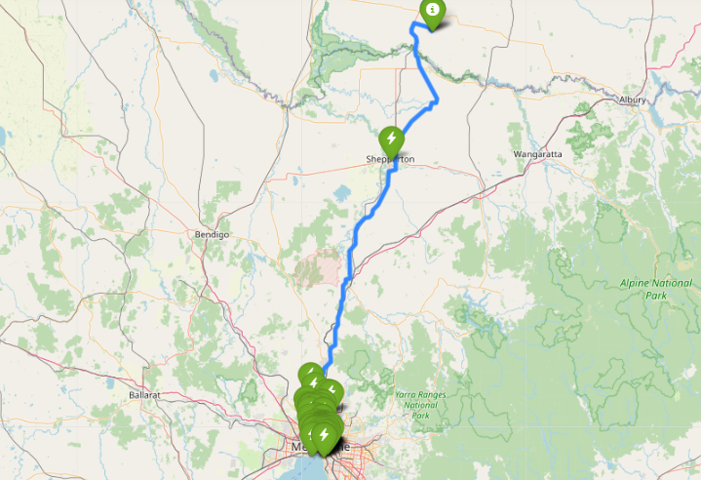

## **DASHBOARDS.**

1. **Demographics of the EV Charging Stations.**

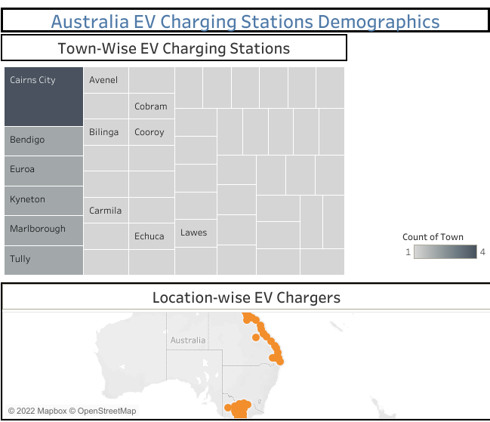

1. **Counts EV Charging Stations Graphs.**

